|  |  |
| --- | --- |
|  | **BAHRIA UNIVERSITY,**  **(Karachi Campus)**  *Department of Software Engineering*  **Fall 2020** |

COURSE TITLE: **Data Communication and Networking** COURSE CODE: **CEN-222**

Class: **BSE - 5B** Shift:**Morning**

Course Instructor: **Engr. Mahawish Fatima** Date:**01-Jan-2021**

Lab Instructor:**Engr. Fareeha Dilawar**

**OEL-II**

**[CLO#2]**

**Q1. Consider the topology given below and perform the following configuration in packet tracer.**

**We can see that, VLAN88 and VLAN98 have been applied across the ports (links). Task is to make Z3, Root bridge (Root switch) for VLAN88 and Z4 root bridge for VLAN98.**

**Port fa0/2 on Z1 is the forwarding port for VLAN88 and blocking port for VLAN98. Similarly, port fa0/2 on Z2 is the forwarding port for VLAN98 and blocking port for VLAN88.**

**Blue color represents the trunk applied on each port. We have already discussed on how to make a root switch and so we can make a secondary root bridge.**

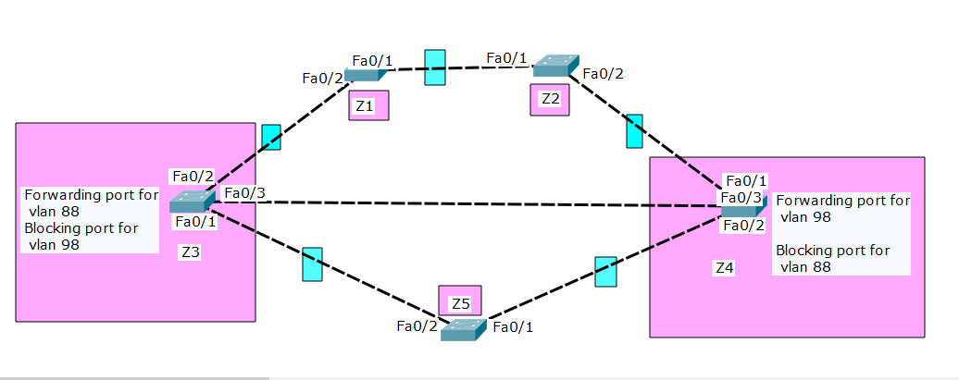

**FOLLOW THE BELOW INSTRUCTIONS:**

1. Make sure to answer the questions as per the processes, commands and logics studied in the lab.
2. Zero plagiarism means no copying from the internet and from others (the one who will copy and the one who shares both will face the consequences).
3. Timely submission is important. failed to do so will lead to 3 marks deduction.
4. Screenshots need to be added for each step.

**Good Luck!**

Setting up topology:

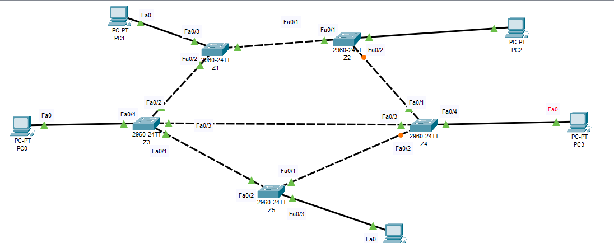

**Assigning ips to pc:**

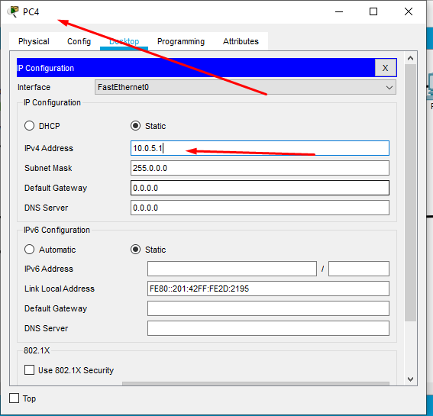

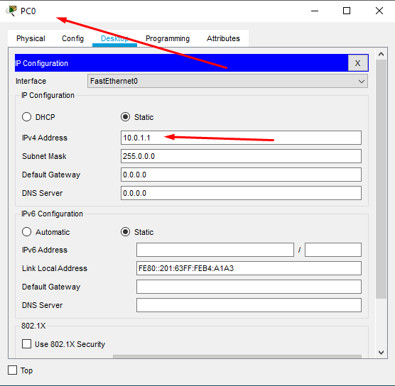

And so on to all pcs

|  |  |
| --- | --- |
| PC Name | IP Given |
| PC0 | 10.0.1.1 |
| PC1 | 10.0.2.1 |
| PC2 | 10.0.3.1 |
| PC3 | 10.0.4.1 |
| PC4 | 10.0.5.1 |
|  |  |

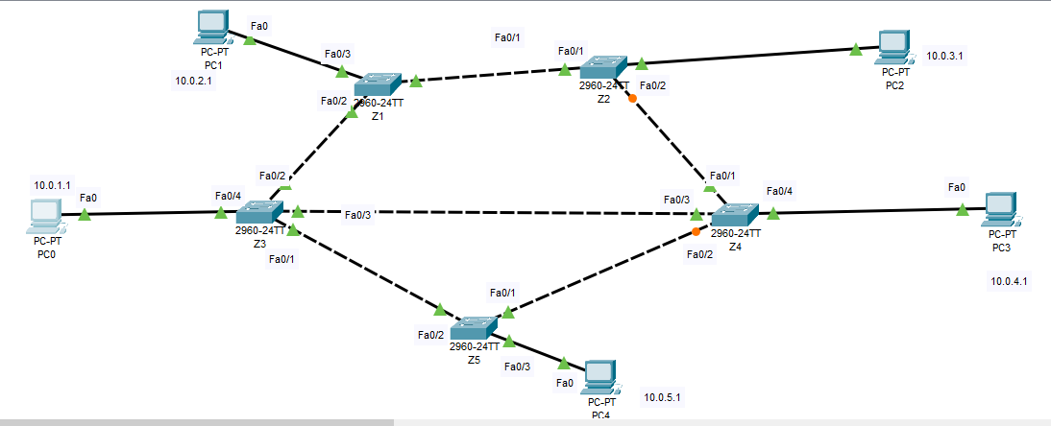

**Setting vlan 88 on Z3**

Switch>en

Switch#conf t

Enter configuration commands, one per line. End with CNTL/Z.

Switch(config)#hostname Z3

Z3(config)#vlan 88

Z3(config-vlan)#name vlan88

Z3(config-vlan)#exit

Z3(config)#int fa0/2

Z3(config-if)#switchport mode access

Z3(config-if)#switchport access vlan 88

Z3(config-if)#exit

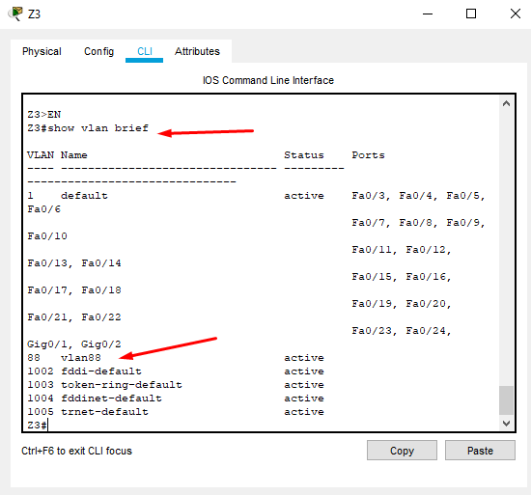

**Setting vlan 98 on Z4**

Switch>en

Switch#conf t

Enter configuration commands, one per line. End with CNTL/Z.

Switch(config)#hostname Z4

Z4(config)#vlan 98

Z4(config-vlan)#name vlan98

Z4(config-vlan)#exit

Z4(config)#int fa0/1

Z4(config-if)#switchport mode access

Z4(config-if)#switchport access vlan 98

Z4(config-if)#exit

Z4(config)#exit

Z4#

%SYS-5-CONFIG_I: Configured from console by console

Z4#

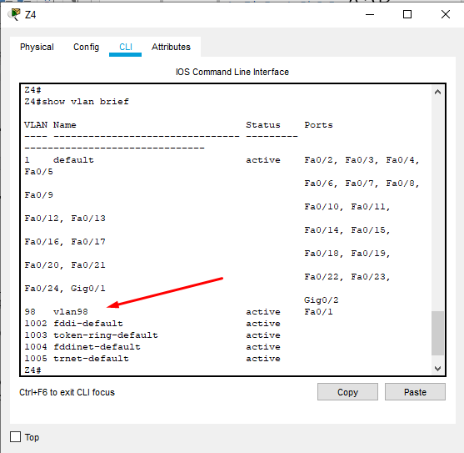

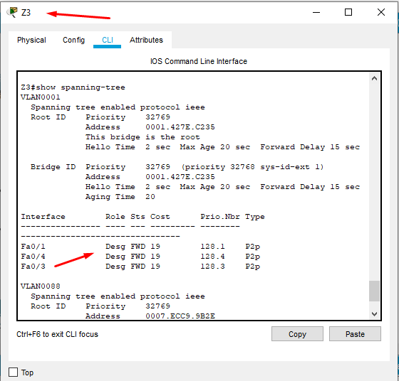

**So switch Z3 is my root bridge for now.**

**Root priority: 32769**

**Address: 0001.427E.C235**

**Root port: No one**

**Designation port: 0/1, 0/4 and 0/3**

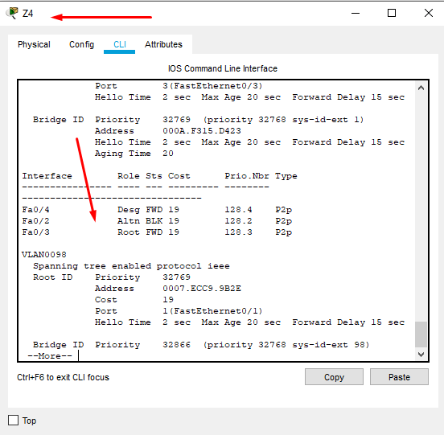

**Making: Z4 root bridge for VLAN98.**

Z4(config)#spanning-tree vlan 98 root primary

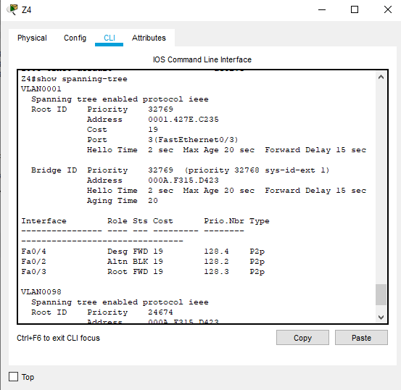

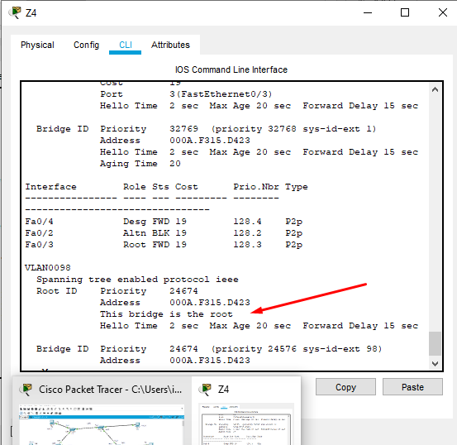

**Making trunk:**

**Z3:**

Z3(config)#interface FastEthernet0/2

Z3(config-if)#

Z3(config-if)#switchport mode trunk

Z3(config-if)#switchport trunk allowed vlan 1-99

Z3(config-if)#exit

Z3(config)#

**Z1:**

Switch>en

Switch#conf t

Enter configuration commands, one per line. End with CNTL/Z.

Switch(config)#int fa0/1

Switch(config-if)#switchport mode trunk

Switch(config-if)#switchport trunk allowed vlan 1-99

Switch(config-if)#exit

Switch(config)#

**Z2:**

Switch>en

Switch#conf t

Enter configuration commands, one per line. End with CNTL/Z.

Switch(config)#hostname Z2

Z2(config)#int fa0/2

Z2(config-if)#switchport mode trunk

Z2(config-if)#switchport trunk allowed vlan 1-99

Z2(config-if)#exit

Z2(config)#

**Z2:**

Z4#en

Z4#conf t

Enter configuration commands, one per line. End with CNTL/Z.

Z4(config)#int fa0/2

Z4(config-if)#switchport mode trunk

Z4(config-if)#switchport trunk allowed vlan 1-99

Z4(config-if)#exit

**Z5:**

Switch>en

Switch#conf t

Enter configuration commands, one per line. End with CNTL/Z.

Switch(config)#hostname Z5

Z5(config)#int fa0/2

Z5(config-if)#switchport mode trunk

Z5(config-if)#switchport trunk allowed vlan 1-99

Z5(config-if)#exit

Z5(config)#

**Digital Pinging:**

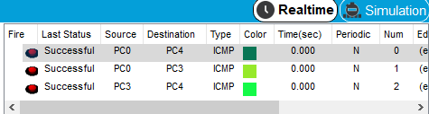

**Pinging pc3 from pc0:**

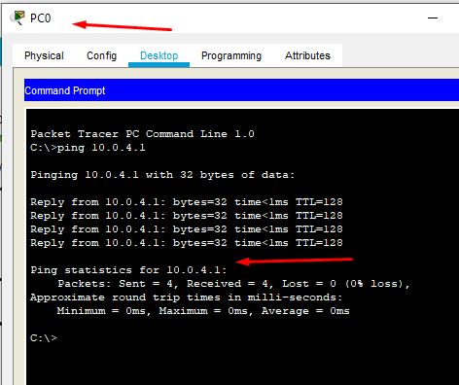

**Pinging pc0 from pc3:**

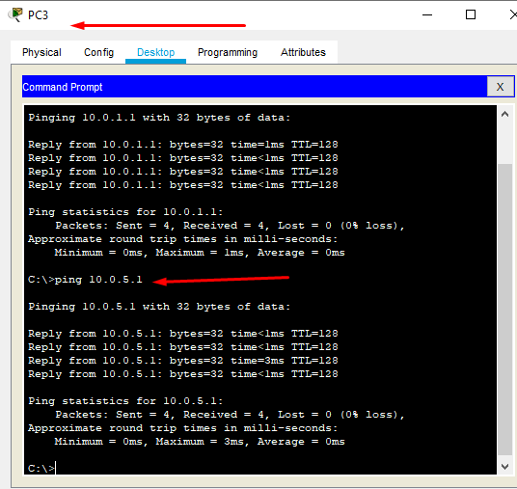

**Pinging pc0 from pc3:**

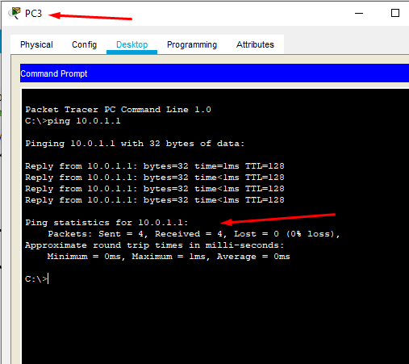

**Pinging pc0 from pc4:**

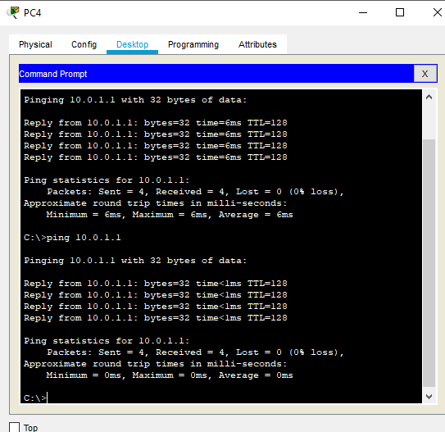

**Pinging pc2 from pc:**

